Instructions for ordering international insurance via Form RM23.

All programs must order the international insurance for student through Risk Management.

#1. Download the student list from your program leader page under “Program Forms” and then “Insurance”:
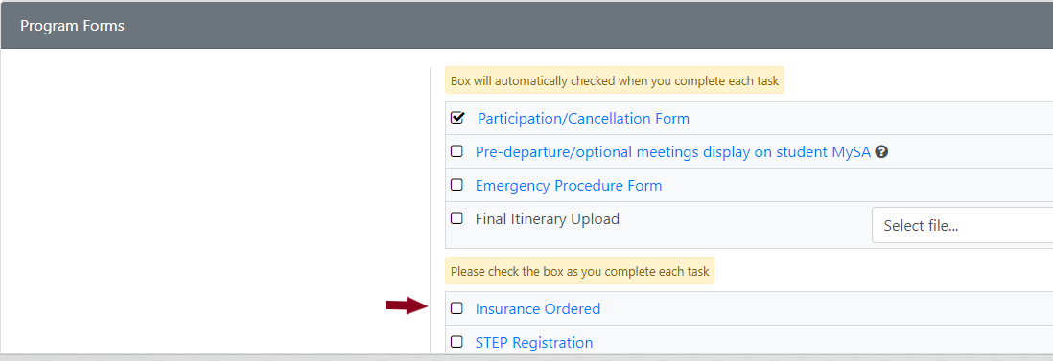
#2. Open the list of students and save to your computer.
#3. Open the Form RM23 (located on the Risk Management forms site).
Please note that this site has been experiencing some issue and Risk Management is currently working with IT to fix.
This site works best in Firefox and you will need to log in with your boilerad\username and password. If you receive an error message, please screenshot the error msg and sent to Lois High, high@purdue.edu for troubleshooting and check in with her before re-submitting).
#4. Complete the top section of the Form RM23 entering the program / department / account information.
#5. Please enter the first student in the fields manually and then use the “click here to attach file” to upload the spreadsheet that you have saved on your computer.
#5. Submit form.
#7. The person listed in the “Send ID Card To” section will receive an email once the students have been entered into Risk Management system.
#8. Notify PL leader or students that the insurance has been ordered and students should carry the Insurance ID card with them during their travels.

